**Sonic Sargam**

**Test Execution Summary Report**

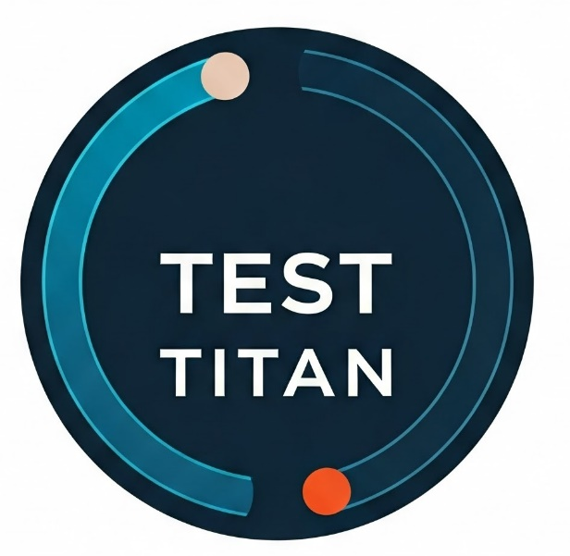

**Prepared by: Atul Pal**

**Submitted To: Masai**

**IA Instructor: Anjali Shaw**

**Approved By: Pooja Yadav**

Contents

1. Summary 3

2. Test Execution Overview 3

3. Key Metrics 4

4. Defect Summary 4

5. Observations 4

6. Recommendations 5

7. Conclusion 5

Signatures: 5

**Test Execution Summary Report**

**Project Name:** SONIC SARGAM  
**Prepared By:** Atul Pal  
**Date:** 22 December 2024

# 1. Summary

This document summarizes the results of the test scenarios executed for the SONIC SARGAM platform. A total of 37 test cases were executed across functional, performance, compatibility, and usability testing types.

# 2. Test Execution Overview

|  |  |  |  |  |
| --- | --- | --- | --- | --- |
| Test Type | Test Scenarios | Number of Test Cases | Passed | Failed |
| Functional Testing | Search, Notifications, Settings, Profile, Register, Login, Trending Songs, Playlist, Top Songs, Player, Menu | 34 | 13 | 21 |
| Performance Testing | Website performance | 1 | 0 | 1 |
| Compatibility Testing | Compatible functionality | 1 | 1 | 0 |
| Usability Testing | Usability functionality | 1 | 1 | 0 |

# 3. Key Metrics

|  |  |  |
| --- | --- | --- |
| Total Test Cases | Passed | Failed |
| 37 | 15 | 22 |

# 4. Defect Summary

|  |  |  |  |
| --- | --- | --- | --- |
| Severity | Total Defects | Resolved | Pending |
| Critical | 10 | 3 | 7 |
| Major | 8 | 2 | 6 |
| Minor | 4 | 4 | 0 |

# 5. Observations

1. **Functional Testing:**
   * Significant failures occurred in the Search, Notification, Settings, Top Songs, and Player functionalities.
   * Playlist and Menu functionalities require immediate attention.
2. **Performance Testing:**
   * Website performance showed issues under high user loads.
3. **Compatibility Testing:**
   * All tests passed successfully.
4. **Usability Testing:**
   * No issues were found; usability was rated satisfactory.

# 6. Recommendations

* Prioritize fixing critical and major defects in the Search, Notifications, and Player functionalities.
* Optimize the website for improved performance under heavy loads.
* Continue monitoring the usability and compatibility aspects post-launch.

# 7. Conclusion

The testing revealed several functional issues that need resolution before launch. With 59% of test cases failing, urgent attention is required to ensure a seamless user experience.

# Signatures:

|  |  |  |
| --- | --- | --- |
| **Role** | **Name** | **Signature** |
| Test Lead | Atul Pal |  |
| QA Manager | Anjali Shaw |  |
| Project Manager | Pooja Yadav |  |